SALURAN INTERAKTIF RSUD KABUPATEN KARANGNAYAR

- POPCAST RSUD
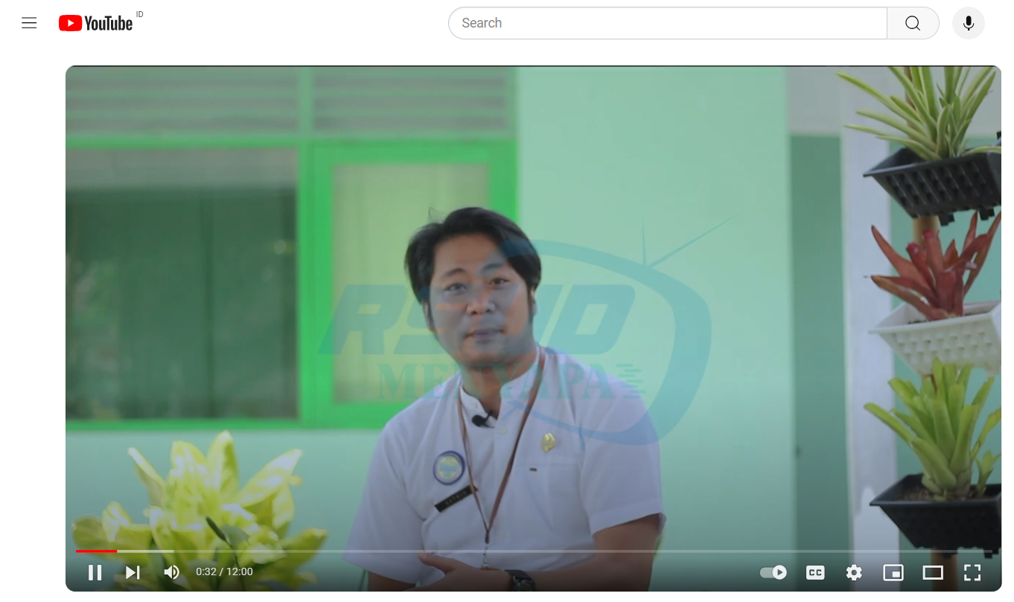
( https://www.youtube.com/watch?v=wJaP8-voViw&t=287s )

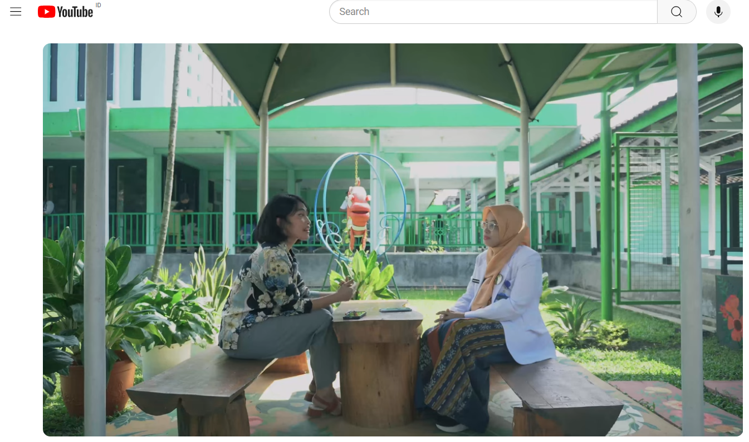
(https://www.youtube.com/watch?v=fg0xz3DxDDQ&t=6s )

